For those who are using Google Colab, please adhere to the following steps:

- Sign in using your Google account and navigate to the Google Colab website:
- The interface displayed below will appear:

- Select Open Colab as shown below:

- The following instance will appear, here you can Upload an existing Jupyter notebook and work. You can also create a New notebook as shown below:
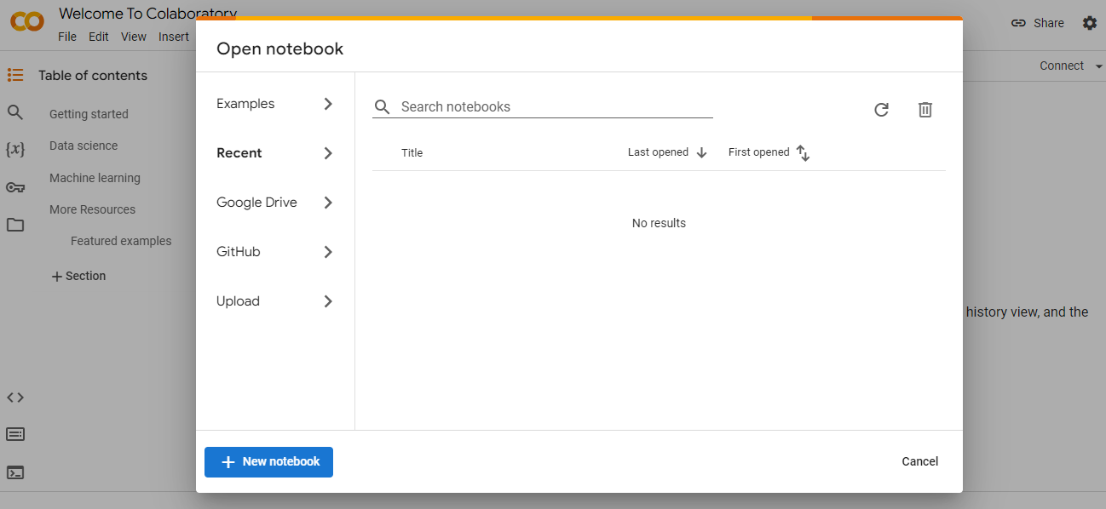

- For dataset integration in the Google Colab environment, use one of the following methods:
- Directly from your local system, through the Google Colab’s left panel
- From Google Drive, via the same panel
- Utilizing the wget command for online sources

